140941353

Running dev_evaluator for 2000 samples i.e. 1000 iterations. Time taken: 5 min

0 iterations have been done in 66.21843600273132 seconds

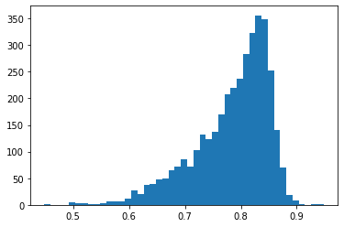

AUC score is 0.5047473020992415 while binary score is 0.49972943722943725 and the confusion matrix is [[ 0 1849]

[ 0 1847]] on dev loader before training

Epoch 0/4

----------

OCloss is 1.7268331050872803 and BCEloss is 0.7786049842834473 and MNRloss is 0.0 and Cosloss is 0.5056589841842651 and time taken is 408.7336630821228 after 0 iterations

/usr/local/lib/python3.7/dist-packages/PIL/Image.py:960: UserWarning: Palette images with Transparency expressed in bytes should be converted to RGBA images

"Palette images with Transparency expressed in bytes should be "

OCloss is 1.38912436300647 and BCEloss is 0.7423742190449537 and MNRloss is 0.0 and Cosloss is 0.5004963038448326 and time taken is 1324.2972037792206 after 500 iterations

image file is truncated (3 bytes not processed)

Something went wrong with the image of id 164569.0

OCloss is 1.389521364089135 and BCEloss is 0.7421202076660408 and MNRloss is 0.0 and Cosloss is 0.49863366155953076 and time taken is 2230.1295680999756 after 1000 iterations

OCloss is 1.3770552757261278 and BCEloss is 0.7414720184718824 and MNRloss is 0.0 and Cosloss is 0.4983116397255663 and time taken is 3133.256873846054 after 1500 iterations

image file is truncated (3 bytes not processed)

Something went wrong with the image of id 164569

image file is truncated (3 bytes not processed)

Something went wrong with the image of id 164569.0

OCloss is 1.3740139565189025 and BCEloss is 0.7409989307785797 and MNRloss is 0.0 and Cosloss is 0.4973913227868402 and time taken is 4034.2132573127747 after 2000 iterations

/usr/local/lib/python3.7/dist-packages/PIL/Image.py:960: UserWarning: Palette images with Transparency expressed in bytes should be converted to RGBA images

"Palette images with Transparency expressed in bytes should be "

OCloss is 1.3716450439649122 and BCEloss is 0.7398404614632723 and MNRloss is 0.0 and Cosloss is 0.4974694878685145 and time taken is 4932.165517568588 after 2500 iterations

Running dev_evaluator for 2000 samples i.e. 1000 iterations. Time taken: 5 min

0 iterations have been done in 0.5959908962249756 seconds

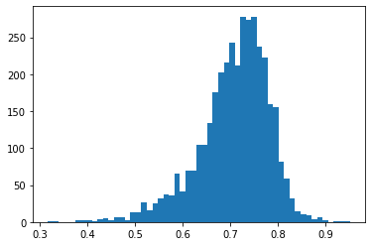

AUC score is 0.5037545776015451 while binary score is 0.49972943722943725 and the confusion matrix is [[ 0 1849]

[ 0 1847]] on dev loader

OCloss is 1.3698372532828018 and BCEloss is 0.7406100315953922 and MNRloss is 0.0 and Cosloss is 0.4977180045749775 and time taken is 6042.468999624252 after 3000 iterations

OCloss is 1.3652735765713755 and BCEloss is 0.7399424913950357 and MNRloss is 0.0 and Cosloss is 0.4976209154029602 and time taken is 6940.209749221802 after 3500 iterations

OCloss is 1.3639146728057976 and BCEloss is 0.7401448756314849 and MNRloss is 0.0 and Cosloss is 0.4977317911942164 and time taken is 7837.261670589447 after 4000 iterations

OCloss is 1.3613133241907276 and BCEloss is 0.7402472643554542 and MNRloss is 0.0 and Cosloss is 0.4979413061228309 and time taken is 8730.460750818253 after 4500 iterations

OCloss is 1.3598337533878722 and BCEloss is 0.7406425740308367 and MNRloss is 0.0 and Cosloss is 0.4981211004758258 and time taken is 9621.940054178238 after 5000 iterations

OCloss is 1.3562654167104908 and BCEloss is 0.7405827089269212 and MNRloss is 0.0 and Cosloss is 0.49800069826534715 and time taken is 10512.302870512009 after 5500 iterations

Running dev_evaluator for 2000 samples i.e. 1000 iterations. Time taken: 5 min

0 iterations have been done in 0.5892598628997803 seconds

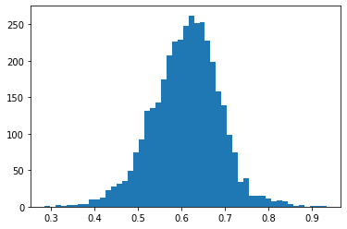

AUC score is 0.5061271456039051 while binary score is 0.49972943722943725 and the confusion matrix is [[ 0 1849]

[ 0 1847]] on dev loader

OCloss is 1.3560450756237956 and BCEloss is 0.7404538367692877 and MNRloss is 0.0 and Cosloss is 0.49782729163763423 and time taken is 11559.200198173523 after 6000 iterations

image file is truncated (3 bytes not processed)

Something went wrong with the image of id 164569.0

image file is truncated (3 bytes not processed)

Something went wrong with the image of id 164569

image file is truncated (3 bytes not processed)

Something went wrong with the image of id 164569.0

image file is truncated (3 bytes not processed)

Something went wrong with the image of id 164569.0

OCloss is 1.3550192144738218 and BCEloss is 0.7403777382718914 and MNRloss is 0.0 and Cosloss is 0.497957494589498 and time taken is 12448.439247846603 after 6500 iterations